Florida International University

Project #3
PR Pico and LCD1602
EML 4804 Introduction to Mechatronics

Submitted By:
Elyion Clyburn
PID 6410764
Date of submission:
09/30/2025

Fall, 2025
Introduction
The goal of this project is to learn how to send messages from a microcontroller to a human operator using an LCD screen while gaining practical skills for working with more complex circuits. By programming the Raspberry Pi Pico to communicate with the LCD1602, I was able to practice writing code that controls hardware, and build experience troubleshooting communication errors between devices. This project also continued my self-guided work with embedded systems applications, where displaying information clearly and reliably is a fundamental task.

Materials used
- Breadboard
- Raspberry PICO board
- LCD screen
- Circuit wires

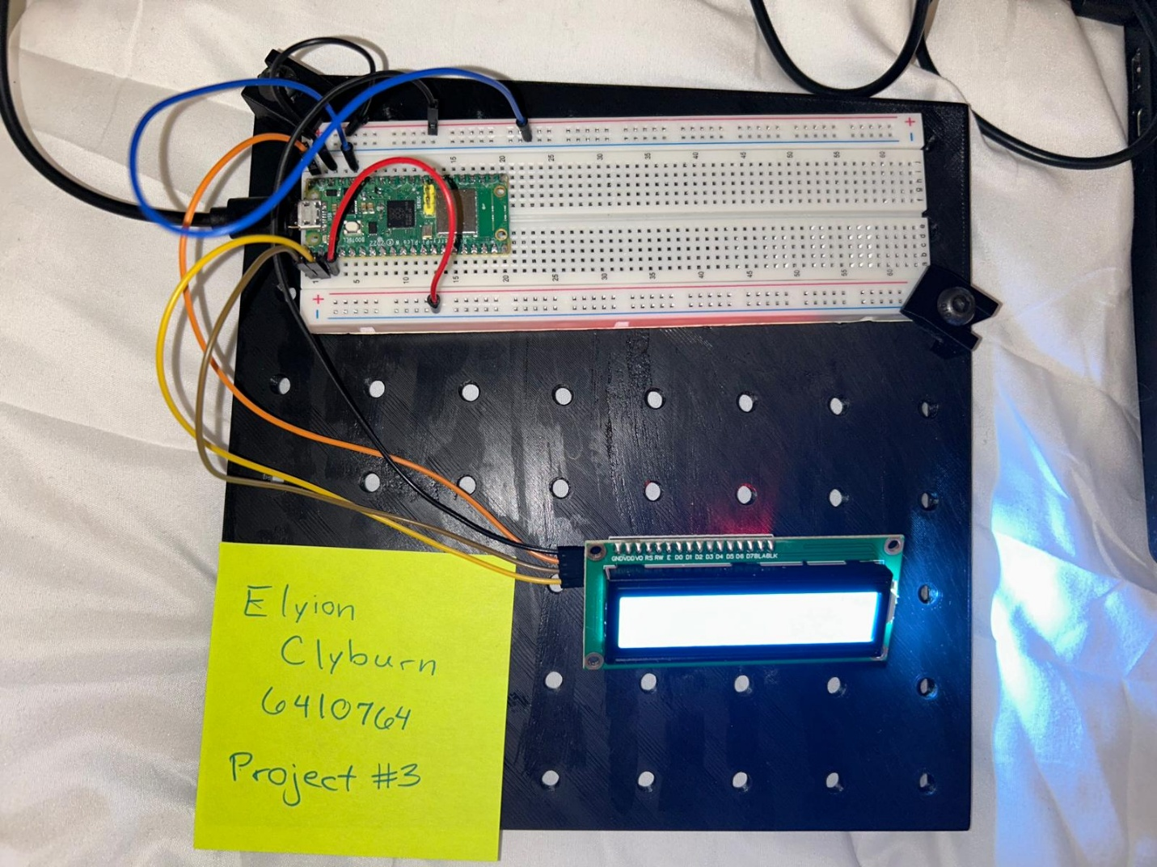
Picture
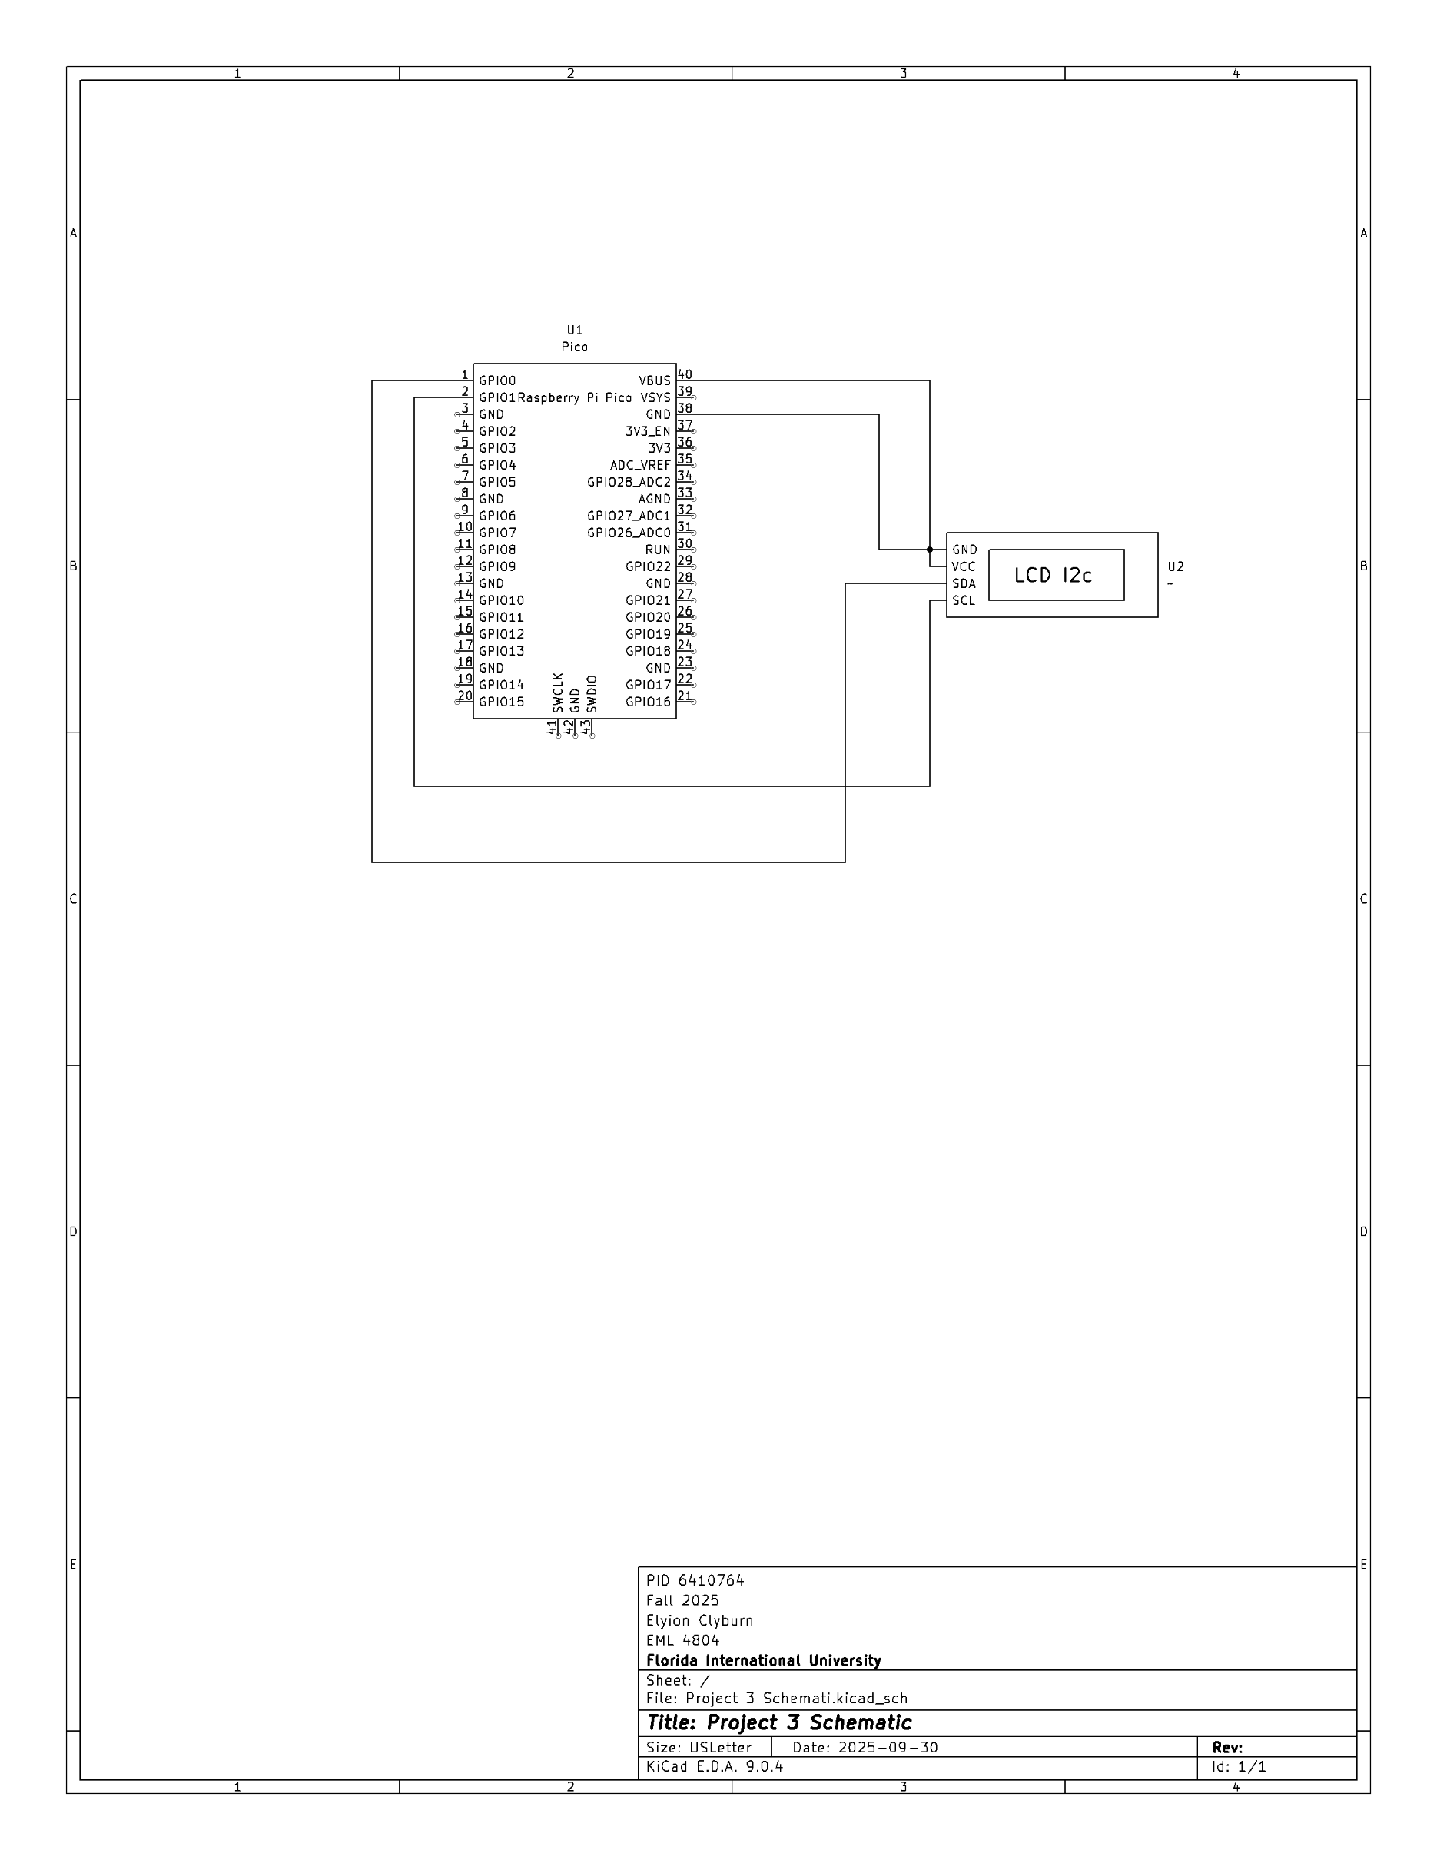
Code
import machine
import time

#Making the library
class LCD():
def __init__(self, addr=0x27, blen=1):
sda = machine.Pin(0)
scl = machine.Pin(1)
self.bus = machine.I2C(0,sda=sda, scl=scl, freq=400000)
#print(self.bus.scan())
self.addr = addr
self.blen = blen
self.send_command(0x33) # Must initialize to 8-line mode at first
time.sleep(0.005)
self.send_command(0x32) # Then initialize to 4-line mode
time.sleep(0.005)
self.send_command(0x28) # 2 Lines & 5*7 dots
time.sleep(0.005)
self.send_command(0x0C) # Enable display without cursor
time.sleep(0.005)
self.send_command(0x01) # Clear Screen
self.bus.writeto(self.addr, bytearray([0x08]))

def write_word(self, data):
temp = data
if self.blen == 1:
temp |= 0x08
else:
temp &= 0xF7
self.bus.writeto(self.addr, bytearray([temp]))

def send_command(self, cmd):
# Send bit7-4 firstly
buf = cmd & 0xF0
buf |= 0x04 # RS = 0, RW = 0, EN = 1
self.write_word(buf)
time.sleep(0.002)
buf &= 0xFB # Make EN = 0
self.write_word(buf)

# Send bit3-0 secondly
buf = (cmd & 0x0F) << 4
buf |= 0x04 # RS = 0, RW = 0, EN = 1
self.write_word(buf)
time.sleep(0.002)
buf &= 0xFB # Make EN = 0
self.write_word(buf)

def send_data(self, data):
# Send bit7-4 firstly
buf = data & 0xF0
buf |= 0x05 # RS = 1, RW = 0, EN = 1
self.write_word(buf)
time.sleep(0.002)
buf &= 0xFB # Make EN = 0
self.write_word(buf)

# Send bit3-0 secondly
buf = (data & 0x0F) << 4
buf |= 0x05 # RS = 1, RW = 0, EN = 1
self.write_word(buf)
time.sleep(0.002)
buf &= 0xFB # Make EN = 0
self.write_word(buf)

def clear(self):
self.send_command(0x01) # Clear Screen

def openlight(self): # Enable the backlight
self.bus.writeto(self.addr,bytearray([0x08]))
# self.bus.close()

def write(self, x, y, str):
if x < 0:
x = 0
if x > 15:
x = 15
if y < 0:
y = 0
if y > 1:
y = 1

# Move cursor
addr = 0x80 + 0x40 * y + x
self.send_command(addr)

for chr in str:
self.send_data(ord(chr))

def message(self, text):
#print("message: %s"%text)
for char in text:
if char == '\n':
self.send_command(0xC0) # next line
else:
self.send_data(ord(char))

#Displaying my name on the LCD screen
from lcd1602 import LCD
import utime

lcd = LCD()
string = " Hello!\n"
lcd.message(string)
utime.sleep(2)
string = " Sunfounder!"
lcd.message(string)
utime.sleep(2)
lcd.clear()
Video Link
https://youtu.be/aUo3NFlBaBA
Conclusion
- What have you learned?
From this project I have learned how to create a new symbol in KiCAD, and how to display text on the LCD screen.
- How difficult was this assignment?
This assignment was not difficult in concept, just difficult to get to work. I would give the difficulty a 5/10 because of this.
- How did you overcome challenges?
The only challenge I came across was the error message “Exception: No LCD found.” I decided to try a few different things in order to get it to work: I changed out the wires, unplugged and plugged back in all my wires, and I even had to go as far as deleting the “LCD1602.py” and “LCD.py” codes from my Raspberry Pico board. It wasn’t until I did the latter, then re-created the codes, that my LCD displayed my name as intended.

References
Home Project #3 PR Pico and LCD1602 Canvas Rubric
2.17 Show Characters on I2 LCD1602 — SunFounder Thales Kit for Raspberry Pi Pico 1.0 documentation
new symbol in KiCAD

